The American search for a canal in Mexico, Nicaragua, or Panama

J. David Rogers, P.E., P.G., M.ASCE¹
¹ K.F. Hasselmann Chair in Geological Engineering, Missouri University of Science and Technology, Rolla, MO 65409, rogersda@mst.edu

ABSTRACT

The Treaty of Guadalupe Hidalgo ending the Mexican American War in 1848 included an provision guaranteeing American right-of-passage and transit across the Mexican Isthmus of Tehuantepec, viewed as the shortest practicable route across Central America, 2,400 nautical miles shorter than the route across the Panama. The California Gold Rush of 1848 brought thousands of gold seekers and soldiers across the Panamanian Isthmus, including future President Ulysses S. Grant. In the early 1850s Americans also established a regular transit path across Lake Nicaragua, which flourished until completion of the First Transcontinental Railroad in May 1869. In 1879 American engineer James B. Eads presented a scheme for a quadruple track ship-railway across the Isthmus of Tehuantepec in Mexico, while other American interests favored the old route through Nicaragua. Led by Suez Canal builder Ferdinand de Lesseps, the French set their sights on Panama in 1881 and began excavating a sea level canal in 1883, similar to that at Suez. While excavating the highlands along the Continental Divide in 1884, damaging landslides began slowing progress at Culebra and Cucaracha. Health epidemics related to outbreaks of yellow fever and malaria killed approximately 5,600 people, including 460 French engineers. The ever-increasing volume of landslides and the death toll bankrupted the enterprise and the French abandoned the project in 1889. Subsequent attempts to re-start construction met with failure in 1894, because the project was under-funded. The French then focused their efforts on selling their franchise and equipment to the United States. This sale eventually succeeded, in thanks to considerable political intrigue, Nicaraguan postage stamps portraying the Momotombo volcano, and American intervention in helping to establish Panama as a sovereign entity, separate from Columbia. Panama from they succeeded in selling their franchise to the United States in 1903, shortly Americans helped Panama separate from Columbia.

INTRODUCTION

American interest in a Central American canal

The American involvement with the Panama Isthmus began with the California Gold Rush in 1848-59, when 50,000 gold seekers struck out for California, with thousands of them passing through Panama, including a young Army Lieutenant named Ulysses S. Grant (in 1852). The 50-mile walk across the isthmus was plagued by the dangers posed by malaria and yellow fever, torrential downpours, and no organized system of transport (travelers often waited for as much as six weeks to ride a donkey across the Continental Divide). Between 1850-55 American interests built the Panama Railroad between Colon on the Atlantic side and Panama City, on the Pacific. Having no competition, it became the most profitable business venture ever traded on the New York Stock Exchange in the 19th Century (McCullough, 1977).

For those emigrants traveling to California by sea who wanted a shorter and quicker path to California, there was the route across Nicaragua, granted by Nicaragua to the Accessory Transit Company, owned by Cornelius Vanderbuilt. American packet ships could sail across the Gulf of Mexico and make landfall at San Juan del Norte. From there vessels of shallow draft could sail up the San Juan River (which forms the border between Nicaragua and Costa Rica) to Lago de Nicaragua, the largest body of water in Central America. On the west side of the lake at Rivas, passengers and goods were then transported by stagecoach or wagon over a narrow path leading to the Pacific, where Vanderbuilt-owned packet ships ran regularly scheduled trips to and from San Francisco. The coordination between vessels running on regular schedules made the Nicaraguan route the fastest and least expensive route to California, for many years. As early as 1826 the Nicaraguan route was viewed as the most likely path for an interoceanic canal, about 172 miles long. This gradually morphed into the Inter-Oceanic Nicaragua Canal, which was favored over any other by both the British and the Americans up until the time the Panama route was purchased from the French in 1904.

The commercial advantages of the Panamanian Isthmus were only part of America’s interest in Panama; the other being an emerging desire to exert American influence in the Pacific Basin and establishing the United States as one of the world’s principal maritime powers. This desire emerged even before the news of discovery of gold in California, because Boston whalers were plying the Pacific to glean whale oil, which was in great demand prior to the drilling of the first oil well in 1859.

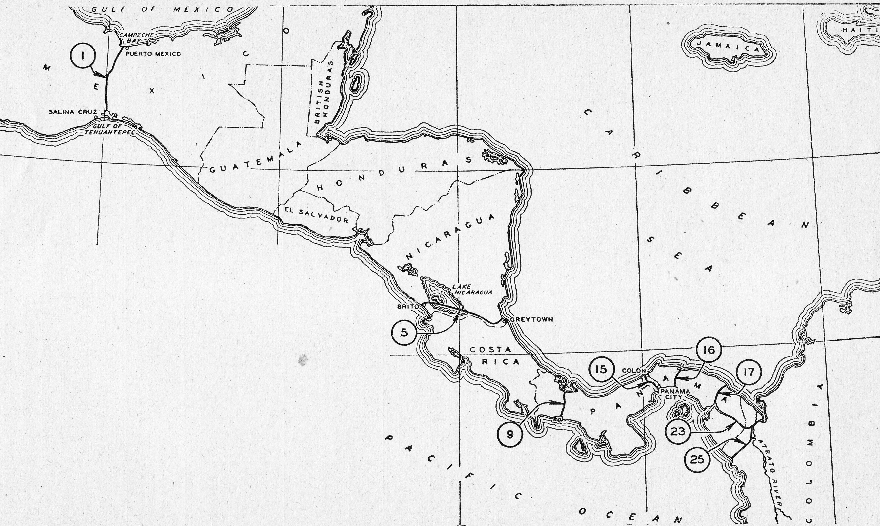
Figure 1. Map showing the various canal routes in Central America, taken from Stratton (1948). Route 1 is the Tehuantepec route through Mexico secured in the Treaty of Guadalupe Hidalgo in 1848. Route 5 is the path through Lake Nicaragua that was first envisioned in 1826. The Panama Canal is shown as Route 15.

This emerging view of manifest destiny in the Pacific was quietly recorded in the Treaty of Guadalupe Hidalgo in 1848, when Mexico surrendered to the United States. One of the clauses in that treaty provided the right-of-passage and transit across the Mexican Isthmus of Tehuantepec, which, on a map, presents an appealing shortcut of 2,400 nautical miles over Panama (Figure 1). For the next 40 years Americans envisioned the construction of a trans-American railway across this “treaty route,” even after the French descended upon Panama in the 1880s.

James B. Eads’ Tehuantepec Interoceanic Ship Railway

James B. Eads (1820-87) was arguably the most famous civil engineer in America during the last half of the 19th Century (references). The consuming passion of the closing decade of his life was a grandiose scheme to construct an Interoceanic Ship Railway across the Mexican Isthmus of Tehuantepec (see Figure 1). It would take advantage of the right-of-passage clause secured in the treaty with Mexico in 1848, easing the political complications and payment of royalties to a foreign government. And, it would save more than 2400 miles of transit in comparison to a Panama Isthmus route (Vollmar, 2003).

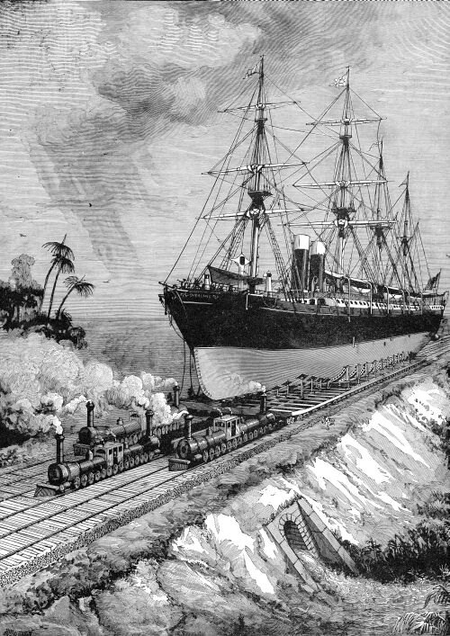
Figure 2. Lithograph illustrating Ead’s concept for a quadruple track ship-railway across the Isthmus of Tehuantepec in Mexico, first advanced in 1879 (from Scientific American, 1888).
During the Panama Canal Congress of 1879 in Paris, Eads proposed the construction of a 143-mile long interoceanic ship railway across the Isthmus of Tehuantepec in Mexico, saving over 2,000 miles over the Panama Route (shown in Figure 2). He developed detailed plans to support his scheme, claiming it would cost about half of what the French were proposing for a sea-level canal across the Panama Isthmus. In 1881 Eads stated he would finance the project himself, asking Congress to guarantee his dividend at 6% interest for 15 years. He died in 1887, never realizing his dream of completing the project.

The Mexican government later funded construction of a railroad across the Isthmus of Tehuantepec, which required four contracts, between 1887-1907. They also constructed a system of quays and railway tracks at terminals on both coasts, to handle heavy cargoes, but the minimum water depth of 33 feet, lack of natural protection from storms, and absence of additional infrastructure more of less doomed the project, which was soon eclipsed by the opening of the Panama Canal in 1914.

THE FRENCH EFFORT

French attempts to build a canal in Panama (1881-94)

Ferdinand de Lesseps (1805-94) was a career French diplomat who was posted to Alexandria, Egypt in 1832-37 (Figure 3). At that time he conceived the idea of excavating a canal between the Red Sea and the Mediterranean. He retired from the diplomatic corps in 1853 and moved to Egypt the following year. By 1856 he had engaged two engineers to draw up suitable plans for a canal, and after convincing others of its practicality, construction commenced in 1859. The 102-mile long Suez Canal was a massive, but geologically uncomplicated job, involving nothing but loose sand. Its successful completion inflated de Lesseps and the French with considerable overconfidence when the canal was completed 10 years later, in 1869.

His success in completing the Suez Canal brought international acclaim to de Lesseps. Desperate to find another project worthy of his genius and vision, de Lesseps set his sights on constructing a sea level canal across the Panamanian Isthmus, which came under the sovereignty of Columbia. De Lesseps envisioned a sea level canal 45-1/2 miles long with a uniform depth of 27-1/2 feet, completed in just under eight years. Over a ten year period he secured the $80 million he believed sufficient to capitalize his newly established Panama Canal Company. Before he was able to begin, the 1879 Panama Canal Congress was convened in Paris. That body estimated that the minimum cost of a sea level canal would be at least $124 million. This made French investors nervous.

In 1880 de Lesseps sent a technical commission to Panama to make final surveys and lay out the path of the great canal, to develop a more precise estimate of the cost. This work was nothing more than a reconnaissance; performing a route survey similar to that performed in laying out railroads. The group’s members only remained in the field for three weeks, working off the old Panama Railroad line. Despite their perfunctory efforts, the technical commission submitted a new estimate of the construction costs, increasing it to $169 million (which included the purchase of the Panama Railroad for $18.7 million).

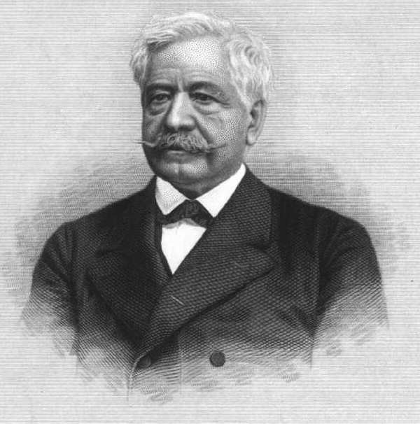
Figure 3. Ferdinand de Lesseps (1805 - 1894) was a retired French diplomat who developed the Suez Canal between 1859-69. He spent the balance of his life trying to construct a sea-level Panama Canal during the 1880s (digital image in the public domain).

Instead of heeding his engineer’s advice, de Lesseps set about reducing the cost of the project by $40 million, to make it more palatable to his investors. Chief among the most outlandish assumptions was that which assumed the new canal would convey six million tons of commercial shipping its first year of operation, thereby generating $18 million per annum payback.

Ever eager to push forward, in December 1881 the French established their headquarters at Panama City. Actual excavation did not commence until January 1883, without any plans whatsoever for sanitation, or how they might combat malaria and yellow fever, which had always plagued the isthmus since as far back as anyone could remember. The French planned to complete the enormous cut across the Continental Divide at Culebra by May 1885.

Excavations on the Continental Divide were carried out in the dry, using railway muck cars. The channel on either coast were being excavated by dredges proceeding inland, as had been their practice in Suez. The French proved both clever and innovative in deploying new types of equipment. This included a floating dredge they assembled in 1883 to excavate the approach channel at Cristobal, on the Atlantic side of the Panamanian Isthmus (Figure 4). By mid 1884 the maximum work force reached 19,000 men, and they began excavating the Continental Divide.

Landslides began to plague the French excavations in the vicinity of Cucaracha and Culebra, severing the rail lines that conveyed muck to disposal areas. As these geological problems slowed progress, health epidemics related to outbreaks of yellow fever and malaria killed approximately 5,600, including more than 460 French engineers.

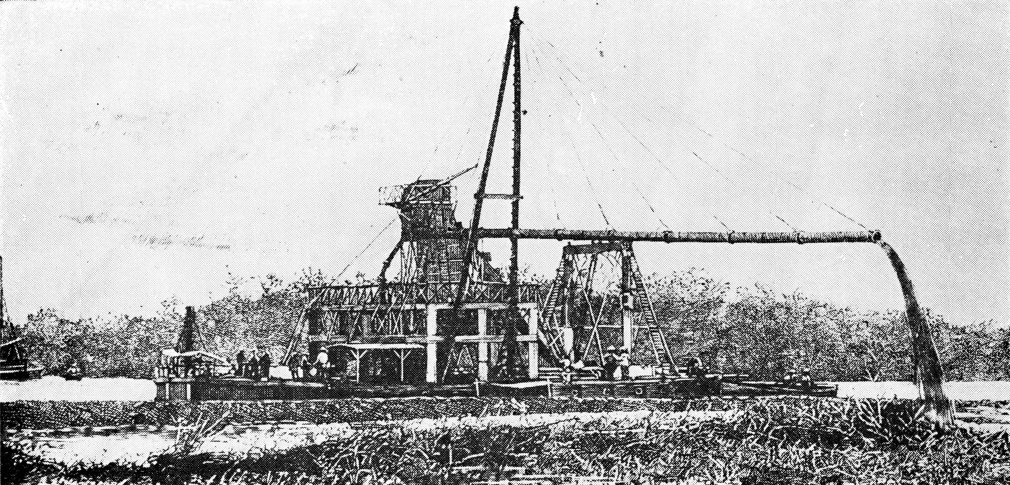
Figure 4. Floating dredge used by the French to excavate the approach channel at Cristobal in 1883 (from Hardy, 1939).

By late July 1885, only about one-tenth of the estimated volume of earth had been excavated. De Lesseps’ engineers revised their cost estimate to $120 million, and requested another four years to complete the project, by July 1889. Undaunted, the French pushed on, if for nothing more than their national pride, as the entire world watched. In May 1885 the French government passed legislation to raise another $125 million through the sale of lottery bonds.

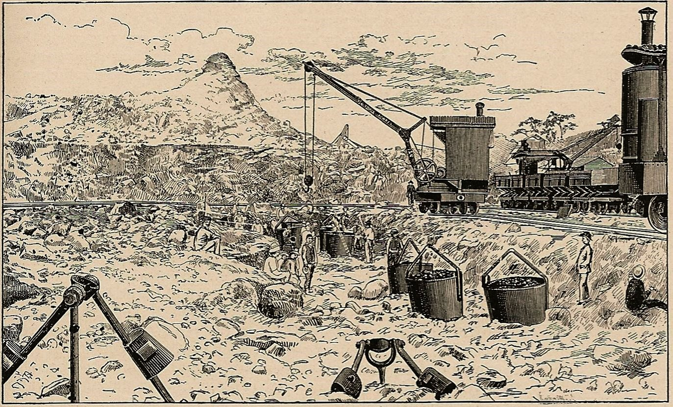
Figure 5. French excavations in the highlands was slow and tedious, employing churn drills, blasting small holes, and steel buckets filled with muck lifted onto rail flatcars, as shown here (from Williams, 1888).

Hoping beyond hope that additional funds would be forthcoming, and refusing to consider any alteration of his original plan for a sea level canal, de Lesseps pushed his forces like a drunken general; all he wanted to see was results.

By June 1886 the French had only managed to lower the Continental Divide by three vertical feet (Figure 5) and the project had already swallowed a whopping $154.5 million. This figure increased to 10 feet by1887, to 20 feet in 1888, ultimately dropping the level 235 of the required 534 feet before the project ground to a complete stop, in May 1889. From 1883-89 the French had succeeded in excavating 78 million cubic yards, at a cost of $233 million (they had excavated 89 million cubic yards for the Suez Canal). This figure did not include annual interest charges in excess of $16 million, which brought the total expenditures/obligations close to $350 million, a staggering sum in the late 1880s.

Liquidation of the French enterprise

The liquidation of the bankrupt French assets took the next 4-1/2 years. In France, disgruntled investors pressured the government to investigate the "Panama Affair," demanding the prosecution of former company officials, including Ferdinand and Charles de Lesseps. Both were found guilty and sentenced to five year prison terms, but the elder de Lesseps died shortly thereafter, in December 1894.

Retaining their franchise with the Columbian government, the French set up a new Panama Canal Company in October 1894. A technical committee had been sent by the liquidators to Panama in late 1890 to take stock of the situation and estimate what it would cost to complete the project. They estimated another $100 million and 10 to 11 more years of construction. A new Panama Canal Company was formed, but with assets of just $13 million, it was grossly under-capitalized. Hoping to attract new investors if they showed substantial progress, key management personnel began returning to Panama in 1895.

A debate raged about whether they should continue pursuing a sea level canal or opt for employing ship locks, which would reduce the volume of required excavation. In February 1896 the French formed a blue ribbon technical committee to review the various studies of both concepts and decide which would be the best for completing the canal, which was completed in mid November 1898. The panel chose a lock canal with two lakes of varying levels, to pass ships across the Continental Divide, using eight sets of locks.

A bond issue was put before the French populace, but their confidence was so low that no investment was forthcoming, and the French government wanted nothing to do with the project. Having spent half their assets by 1898, the French company had few choices, either to abandon the project or sell it. The firm’s directors decided to offer their entire operation to the United States for $109 million.

CAMPAIGN FOR AN AMERICAN CANAL

A canal across the Central American Isthmus was crucial to the development of a two-ocean American Navy. The battleship USS Oregon (BB-3) was the first capital ship built for the U.S. Navy on the west coast, in Mare Island between 1890-96, and became flagship of the U.S. Pacific Fleet, guarding the west coast. Soon after the battleship Maine exploded in Havana Harbor on February 15, 1898, the Oregon was ordered to sail over 14,000 miles, from San Francisco to Santiago, Cuba.

The venerable battleship made the transoceanic trip around Cape Horn is just 66 days, garnering considerable headlines. But, Navy leaders recognized that the Oregon's 9-1/2 week delay could have been cut to just three weeks if the canal across Panama had been operational. The other important factor was the new American presence in the Pacific Basin, from the possessions gained during the Spanish American War (the Philippine Archipelago and Guam, in the Marianna Islands).

In 1899 the American government established an Isthmian Canal Commission to examine the possibilities of a Central American canal and recommend the best possible route to Congress. Most politicians favored a canal through Nicaragua because it looked to be a shorter route on a map, using Lake Nicaragua in the same way de Lesseps used Lake Suez along the Suez Canal. But, a sea level canal was impractical because it would drain the lake, and there were active volcanoes in Nicaragua.

The French offer their works to the United States

Philippe Bunau-Varilla (1859–1940) was a French military engineer educated at Ecole Polytechnique, who served as the de Lesseps’ manager of organization and food distribution in Panama from 1884 onward (Figure 2). When the French consortium was reorganized in 1894, Bunau-Varilla invested everything he had. For Bunau-Varilla the completion of the Herculean task was a matter of national pride, and he reacted with vigor to those who suggested that a canal could never be built across the Panamanian Isthmus.

After attempts to re-capitalize the new corporation failed, Bunau-Varilla volunteered to champion the French efforts to sell their plans, equipment, and franchise to the United States. Previous entreaties had been rebuffed by President Grover Cleveland during his second term (March 1893-March 1897), but with the American interest garnering so many headlines, the French consortium hoped they could market their technical reports, construction equipment and incomplete works to the Americans, as well as their agreement with the Columbian government.

Arriving in New York, he wisely engaged New York attorney William Nelson Cromwell to aid him in lobbing the American President and Congress in Washington, DC. A civil engineer by training, Bunau-Varilla was more knowledgeable about Panama than anyone else in Washington, and he would demonstrate remarkable political acumen as an effective lobbyist over the next few years. Through Cromwell’s connections, Bunau-Varilla gained an official audience with President William McKinley on December 2, 1899, not long after the American victory in the Spanish American War and the acquisition of Cuba and Puerto Rico.

Nicaragua versus Panama

In November 1901, the American’s Isthmian Canal Commission reported to Congress that a canal should be built through Nicaragua unless the French were willing to sell out for no more than $40 million (the great bridge engineer George S. Morison was the only commissioner who favored a canal in Panama). $40 million was a far cry from the $109 million price tag the French were asking. As the debate between Panama and Nicaragua raged in Congress, a fortuitous event occurred in Nicaragua. In May 1902 the Momotombo volcano overlooking Lago Nicaragua erupted, and was featured on Nicaraguan postage stamps (Figure 2).

Panama advocates warn that a Nicaraguan canal might be destroyed by fire and lava. Nicaragua advocates responded that Panama’s earthquakes were just as bad. Bunau-Varilla mailed a letter to every U.S. Senator with a Nicaraguan postage stamp, showing the erupting volcano, shown in Figure 6.

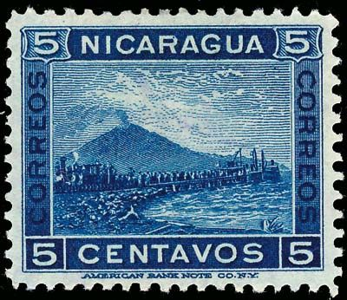  The volcano stamp | 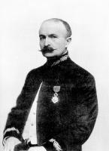
Figure 6. Left image shows an example of the Nicaraguan stamps that portrayed the Momotombo volcano erupting. French military engineer Philippe Bunau-Varilla is shown at right. He lobbied American senators and congressmen for 2-1/2 years, until passage of the Spooner Act in June 1902 (author’s collection [left] and Library of Congress [right]).

President Teddy Roosevelt favored purchasing the French canal excavations, but the U.S. Senate preferred a canal in Nicaragua, where considerable American skill and effort had already been expended. Using their “volcano stamps,” Bunau-Varilla and Cromwell convinced the senators to pass the Spooner Act of 1902 by a vote of 42 to 34, which appropriated $40 million for the purchase the New Panama Canal Company from the French. However, these funds were contingent upon the United States negotiating a treaty with Colombia to provide land for the canal in its territory.

Encouraging Panamanian independence

The American Secretary of State John M. Hay then undertook negotiations with the Columbian government’s representative, Dr. Tomas Herran. In January 1903 the two men signed Herran-Hay Treaty, which allowed the Americans to lease in perpetuity a 6-mile wide strip of land along the Isthmian Canal for $10 million, with an annual royalty of $250,000, both payable in gold. Knowing that the Americans had agreed to pay $40 million to the French, the Columbian senate refused to ratify the treaty.

Teddy Roosevelt was livid, and a majority of those representatives on Capitol Hill were unwilling to renegotiate a new treaty, viewing it as nothing more than simple extortion, after an honorable deal had been brokered by their designated representative. The Americans soon found means of circumventing the Columbians by lending political and military support to separatists in Panama, led by Dr. Manuel Amador Guerrero. American agents were promptly dispatched to encourage Guerrero and his supporters to declare their independence from the Columbian government, and then request armed assistance from the United States. The declaration was made on November 3, 1903 and Columbian officials were ousted from the Isthmus. Roosevelt dispatched the U.S. Navy to both sides of the Panamanian Isthmus, even landing Marines to guard the Panama Railroad (an American owned asset). These forces were more than sufficient to deter any counterattack by Columbian forces.

Without sufficient military might to take on the Americans, the Columbians found themselves dealt out of any further negotiations, which began anew with the newly recognized Panamanian government. On November 18th the United States signed the Hay-Bunau-Varilla Treaty with the new Republic of Panama, which had named Philippe Bunau-Varilla as their principal negotiator with the Americans (the treaty was negotiated in New York and in Washington, DC). The Americans received rights to a 6-mile wide canal zone in perpetuity, and the new republic was to receive a one-time payment of $10 million and an annual rent of $250,000 (the same conditions that had been rejected by the Columbian government). The Americans didn’t actually take over ownership of the French assets on the ground in Panama until May 4, 1904.

CONCLUSIONS

The moving force behind all of these machinations was American President Teddy Roosevelt, who was a stalwart proponent of sea power, having written his book on the subject (The Naval War of 1812) at age 23. He went onto serve as the youngest Assistant Secretary of the Navy under President McKinley, and was in McKinley’s inner circle when the United States declared war against Spain in April 1898. Roosevelt was an advocate of American Navy Captain Alfred Thayer Mahan’s 1890 treatise titled The Influence of Sea Power upon History, which credited the Royal Navy with establishing Great Britain as the premier world power. Mahan was eventually promoted to admiral and his book became the blueprint for American naval prowess for well over a century.

Roosevelt viewed the Panama Canal as vital to America's destiny as a two ocean naval power, able to service and protect our possessions in the Pacific. He pushed Congress to acquire the French rights to the Canal because he viewed it as the least problematic of the various routes, not requiring locks that would be time-consuming for transit, and vulnerable to break-down or attack. He also believed that an American canal would strengthen American influence on Central and South America, and do much to establish the United States as the world’s premier maritime power, a position of influence then dominated by Great Britain.
ACKNOWLEDGEMENTS

The author’s interest in the Panama Canal was piqued in graduate school at Cal Berkeley through the fascinating tales told by Professor J. Michael Duncan about the slope stability problems that befuddled engineers over three-quarters of a century. The writer served as a naval intelligence officer at Rodman Naval Base in the Canal Zone, where he was shown generous hospitality by engineers of the Panama Canal Commission, including George Berman, Luis Alfredo, Carlos Reyes, Maximillian DePuy, and Pastora Franceschi. The writer is also indebted to the staff of the old Panama Canal Commission Library and Technical Resources Center, in particular, librarian Nan S. Chong, who supplied access to thousands of photos.

REFERENCES

Hardy, Rufus. (1939). The Panama Canal 25th Anniversary, Aug. 15, 1914-Aug. 15, 1939. Panama Canal Press, 111 p.
McCullough, D. (1977). The Path between the Seas, Simon & Schuster, New York.
Scientific American. (1884). The Interoceanic Ship Railway. Scientific American, 51:26 (Dec 27, 1884), p. 428-431.
Stratton, J. H. (1948). The Future and the Panama Canal. ASCE Proceedings 74:4, p. 444-468.
Vollmar, J.E., Jr. (2003). "The Most Gigantic Railroad". Invention and Technology, 18:4, p. 6
Williams, W.P. (1888). Plant and Materials of the Panama Canal. ASCE Transactions 19:273-310.

